SQL PROJECT

STUDENT MARKS

**NAME: SHRADDHA THIK**

**COURSE: MASTER IN DATA SCIENCE AND ANALYTICS WITH AI**

**About Dataset:**

The data attributes include student grades, subjects, social and school related features and it was collected by using school reports and questionnaires.

The Subject scores of each student in a particular class is a data set.

**Column Description:**

**\*Marks**

**\*Student_ids**

DATASET FROM: Kaggle

# Entity Relationship Diagram

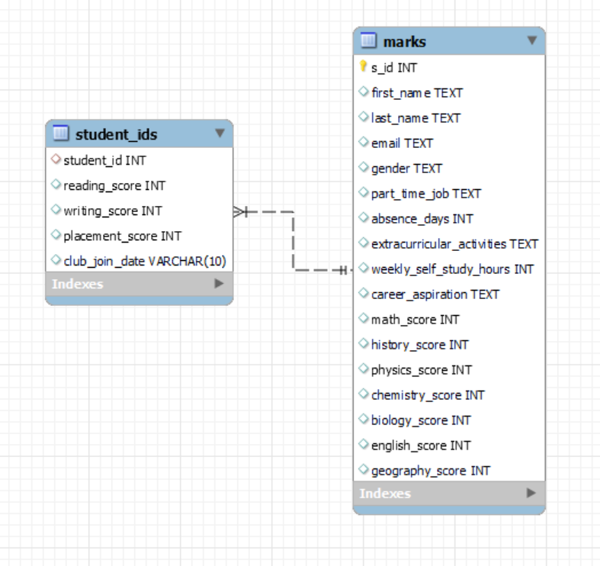

1. show the schema of the tables

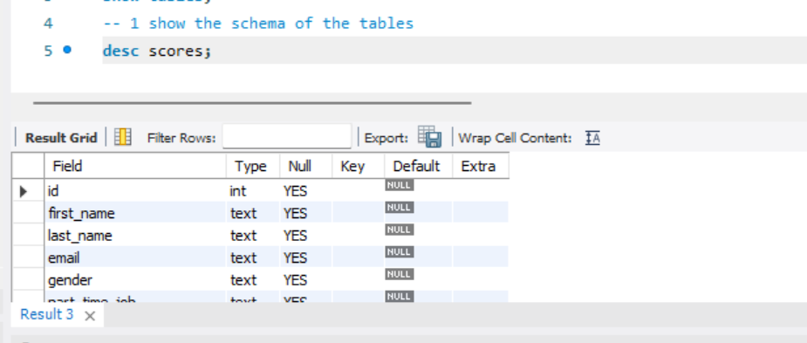

1. add primary key in table scores at id column

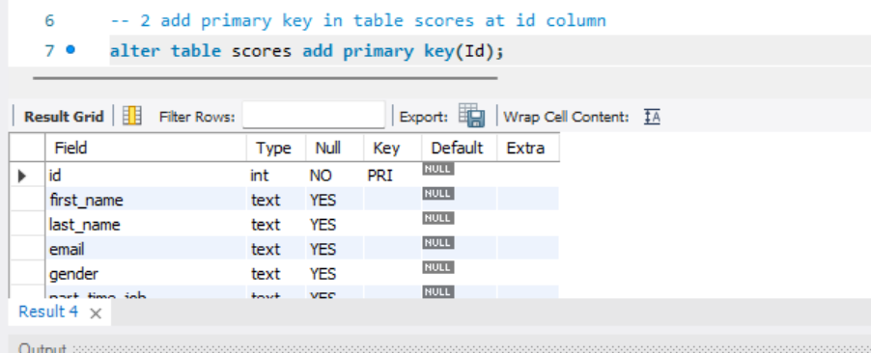

1. create second table named as perform with foreign key

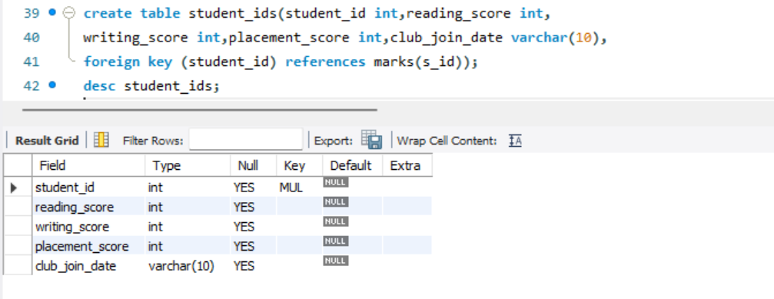

4.show whole record of table scores

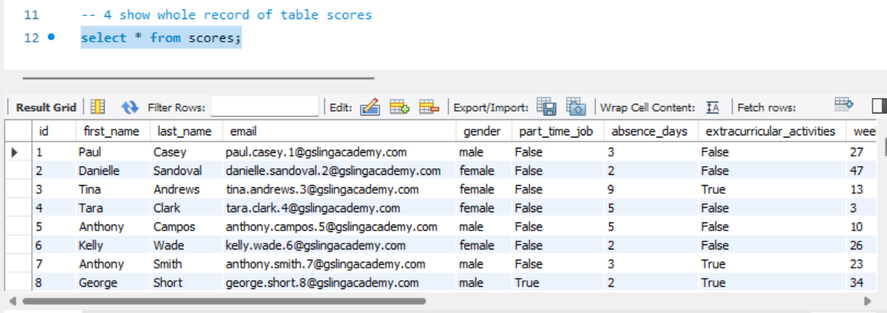

1. write query to change table name scores to marks

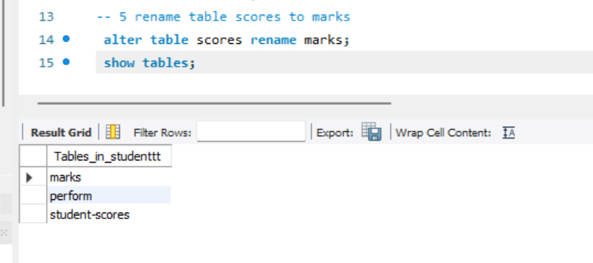

1. Modify the column name id to s_id

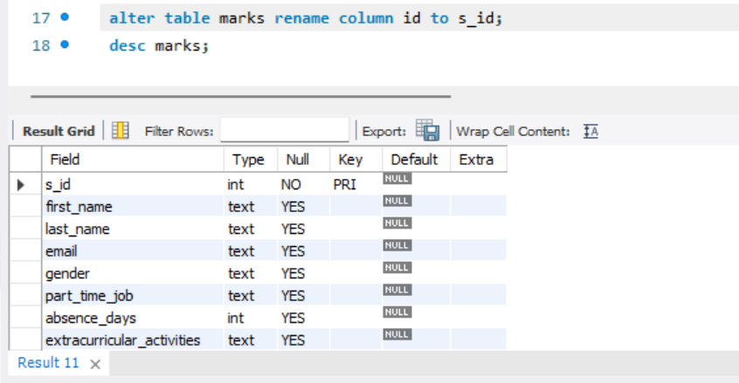

1. Write a query to fetch gender using distinct.

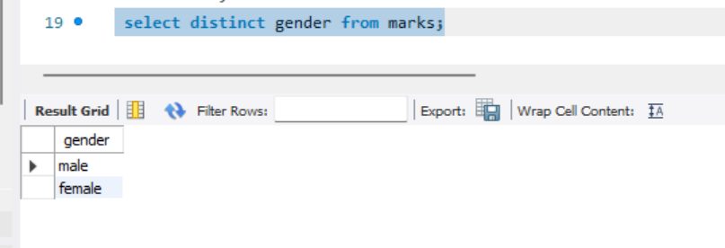

1. **Find students whose last name starts with 'S'**

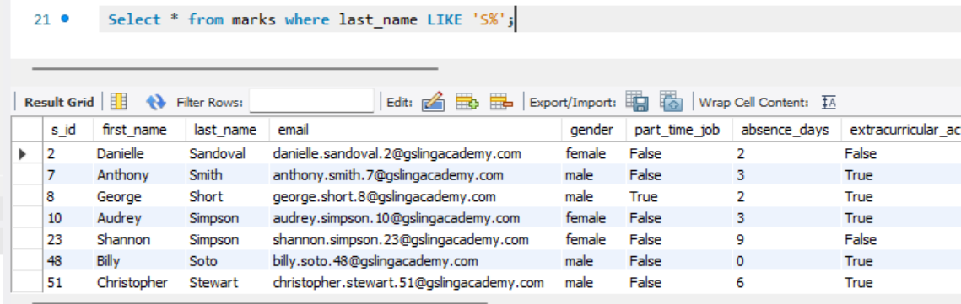

1. **Display students sorted by their math_score in descending order**

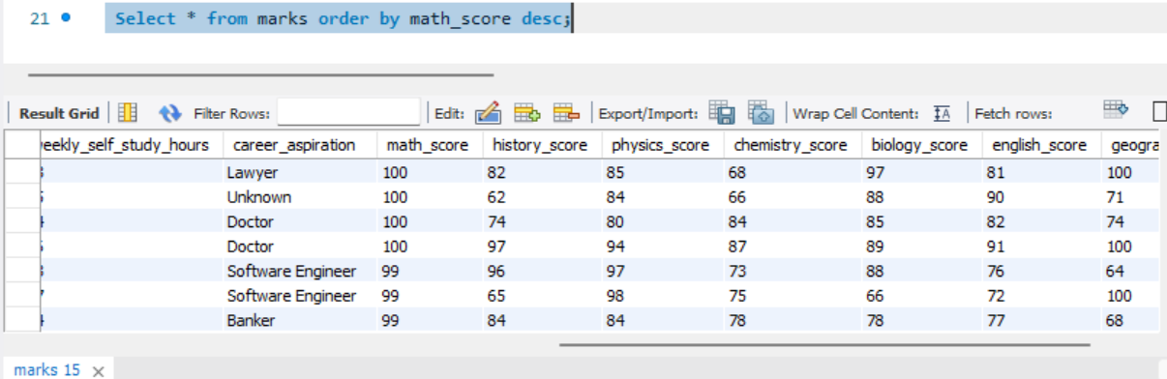

1. **Fetch the first_name, last_name, and history score of student greater than 80**

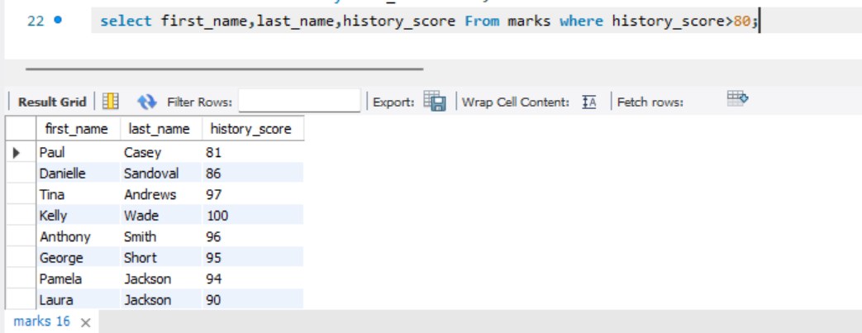

1. **Calculate the total number of students**

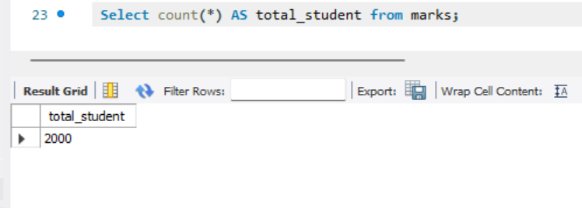

1. **Find the maximum minmun score in English**

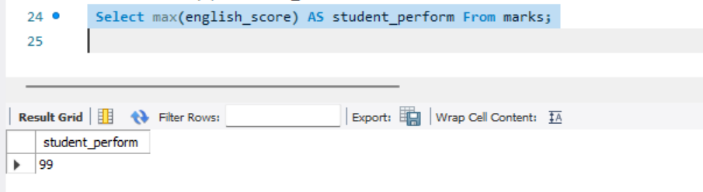

1. **Find the maximum minmun score in English**

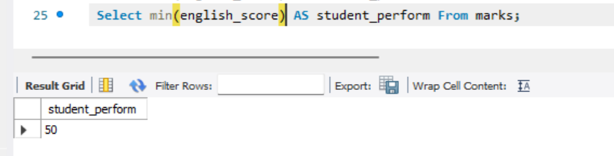

1. Write query to fetch data where physics score is between 70 to 80

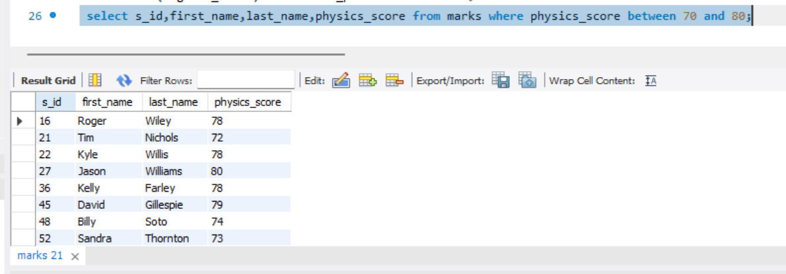

1. Write query to fetch data where physics score is not between 70 to 80

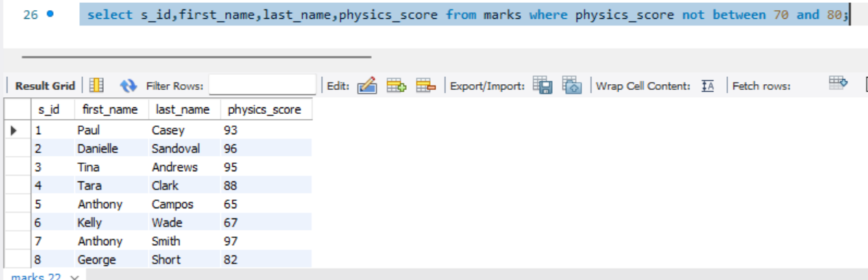

1. Write query to fetch data where chemistry score is 70, 80 or 90.

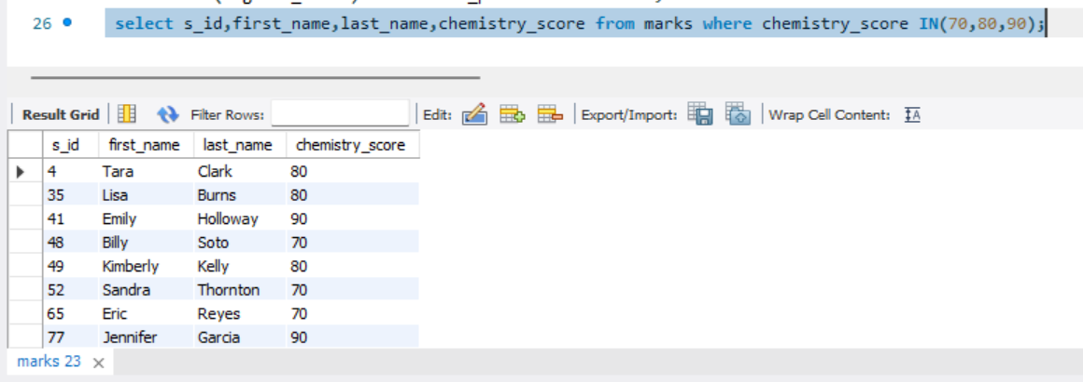

1. Write Query to fetch data where student name starts from c.

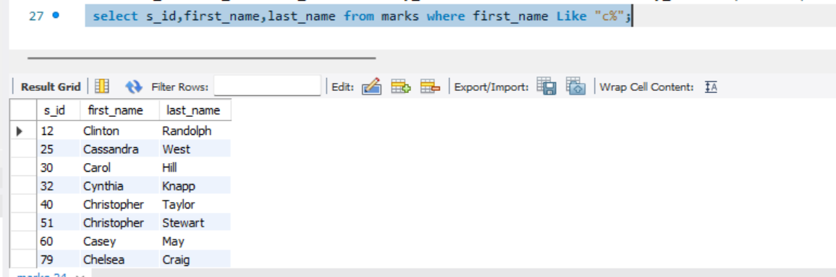

1. Write Query to gives first_name in upper case

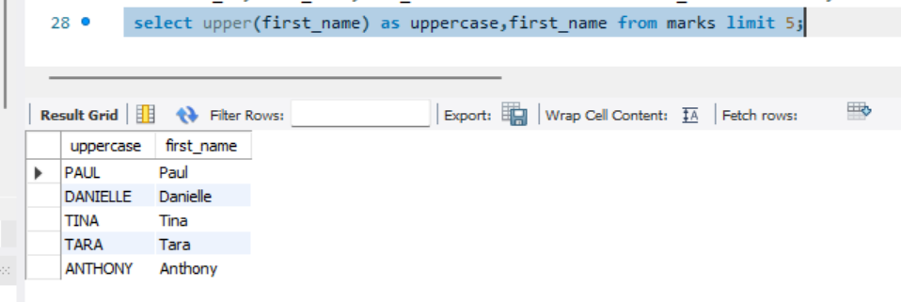

1. Using date function

Now()

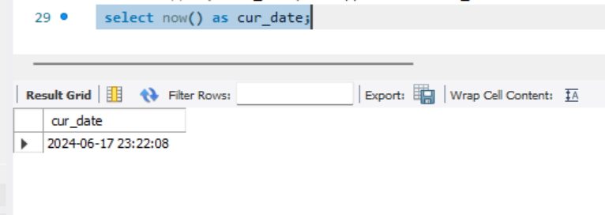

Curdate()

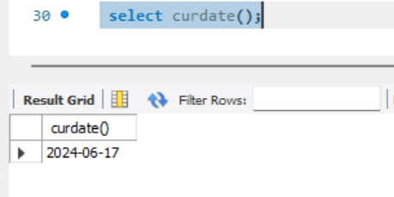

1. Write query to fetch number of students in table

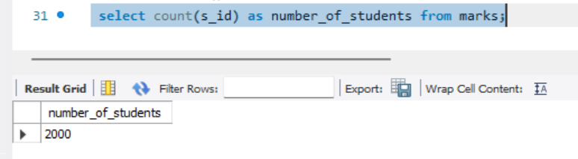

1. Write Query to fetch students first name whose number of math score are more than 2.

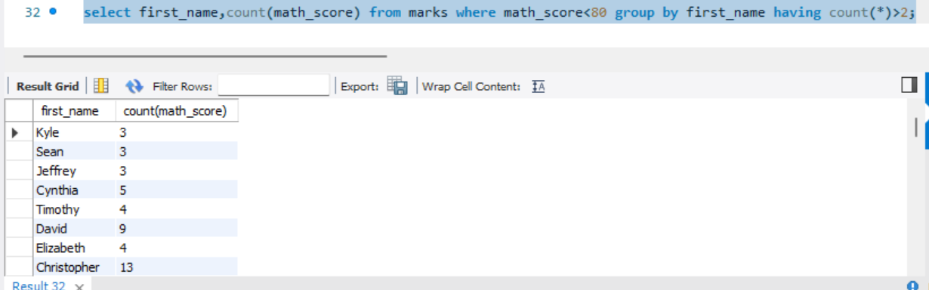

1. Write Query to find highest geography_score of students using subquery

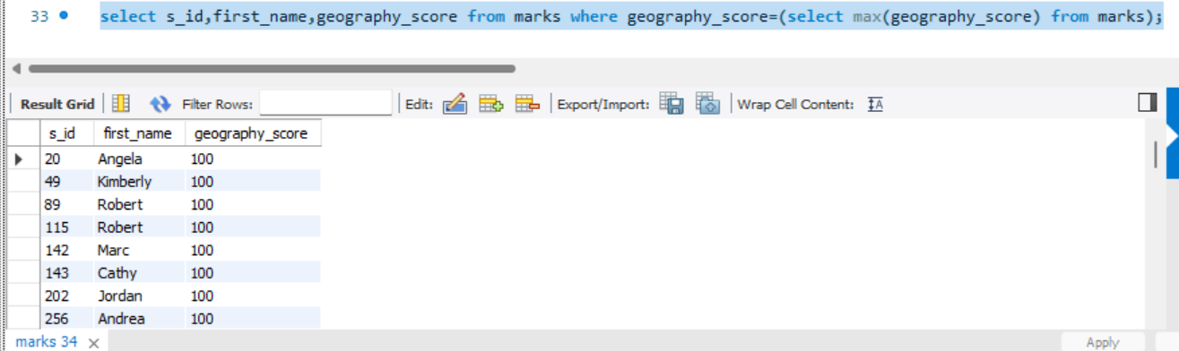

1. Using Concat string function for students full name

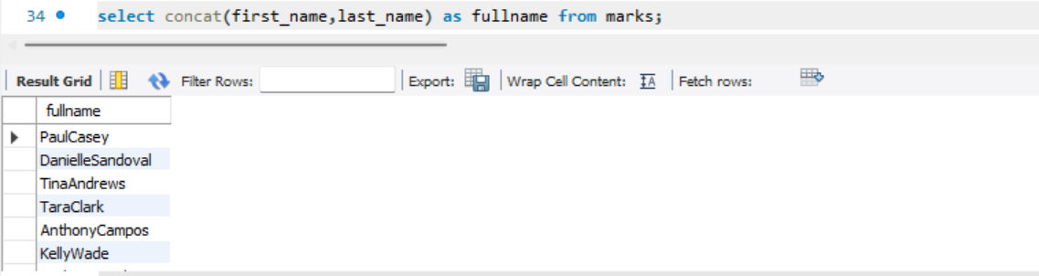

1. Joins

Inner Join

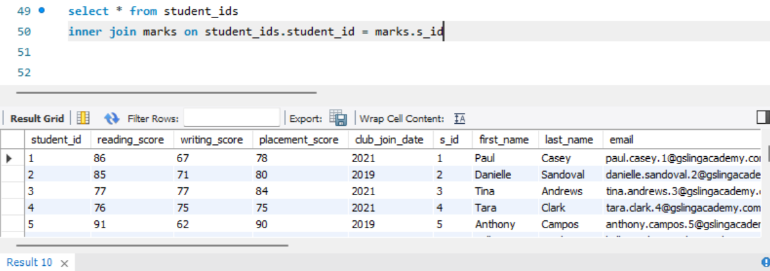

Left Outer Join

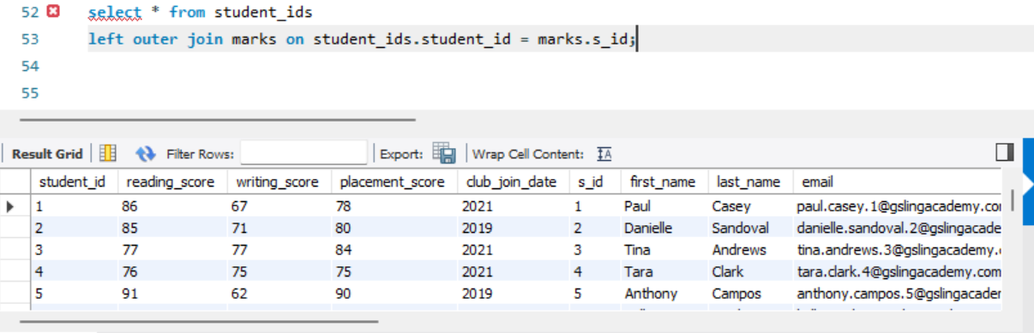

Right Outer Join

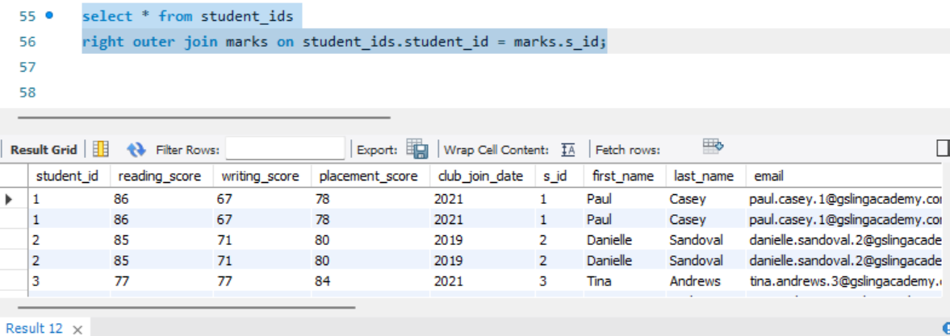

Cross Join

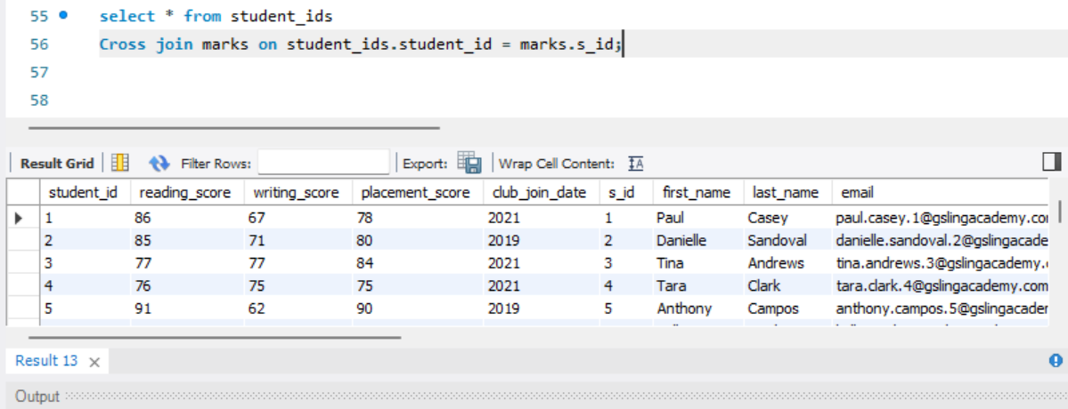

1. Create View

